CLOUD COMPUTING LAB

LAB 10

SUBMITTED TO: SIR SHEHZAD

SUBMITTED BY: TANZEELA ASGHAR

REGISTRATION NO: (2021-BSE-032)

# LAB OBJECTIVE:

INSTALL AND CONFIGURE KEYSTONE

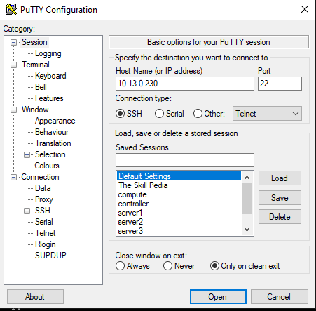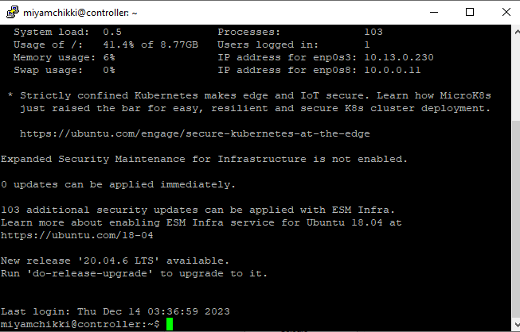

1. **CREATE DATABASE KEYSTONE**

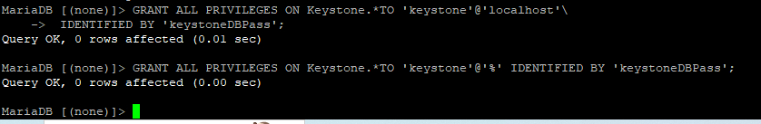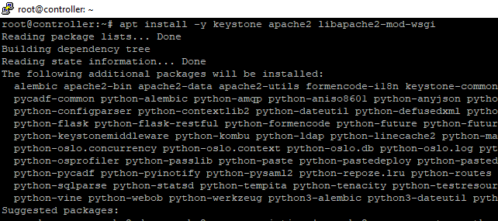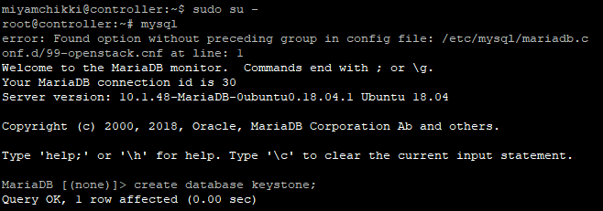

1. **PACKAGES INSTALLATION:**
2. **Edit /etc/keystone/keystone.conf**

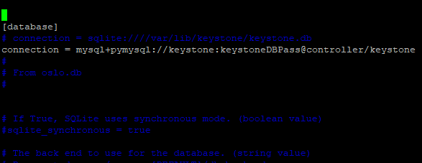

1. **POPULATE DATABSE:**

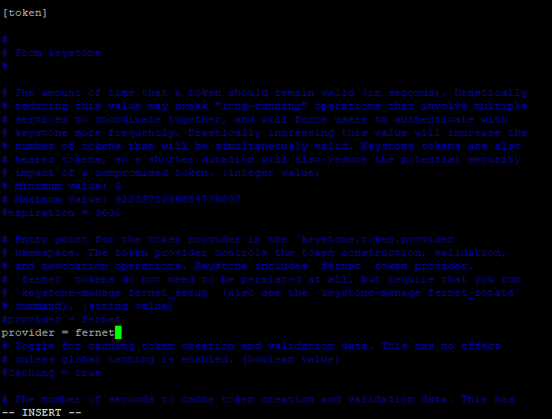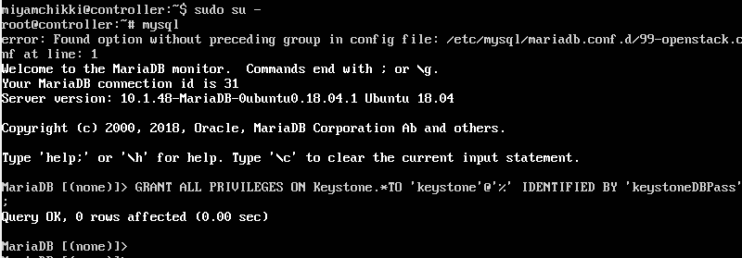

1. **SHOW DATABASE:**

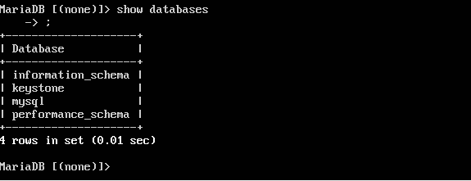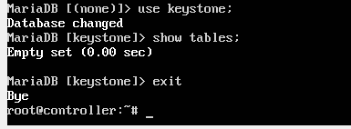

# PROBLEM:

SHOWING EMPTY DATABASE:

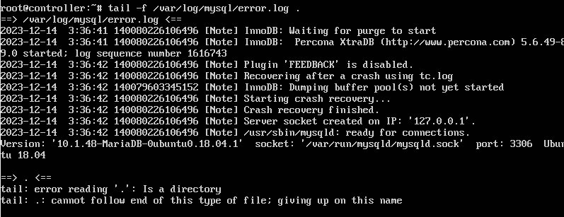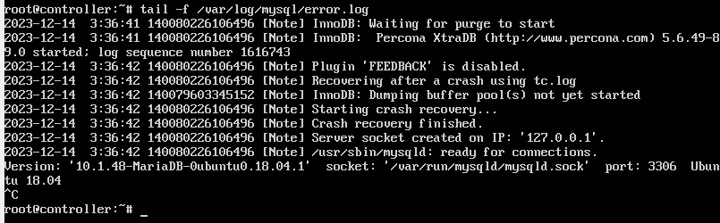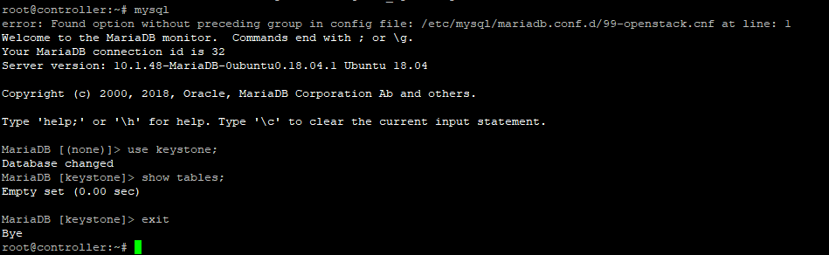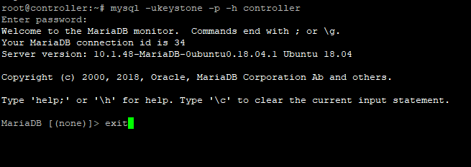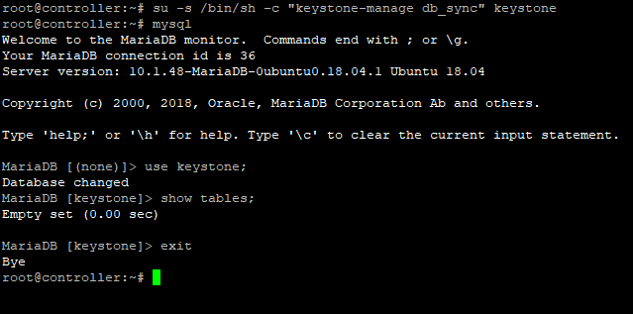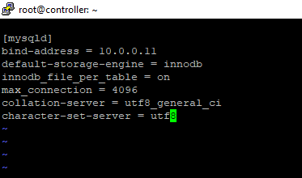

# SOLUTION:

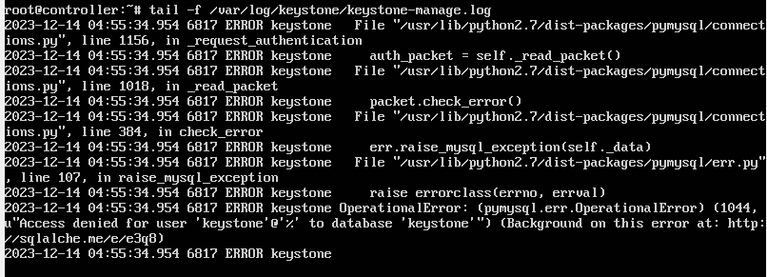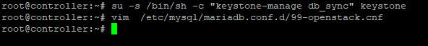

Drop keystone database

Again, create keystone database Restart and then show tables

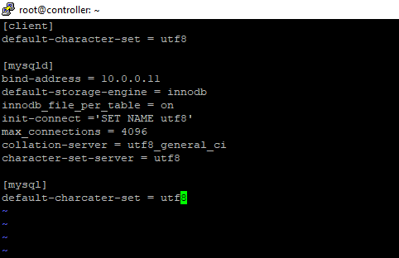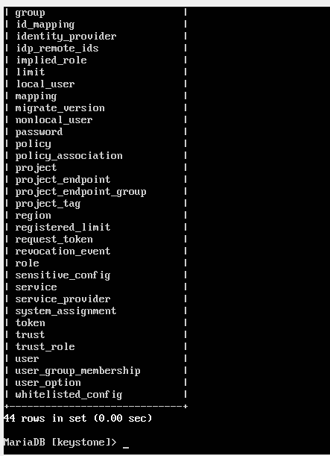

SHOW TABLES ON PUTTY AS WELL:

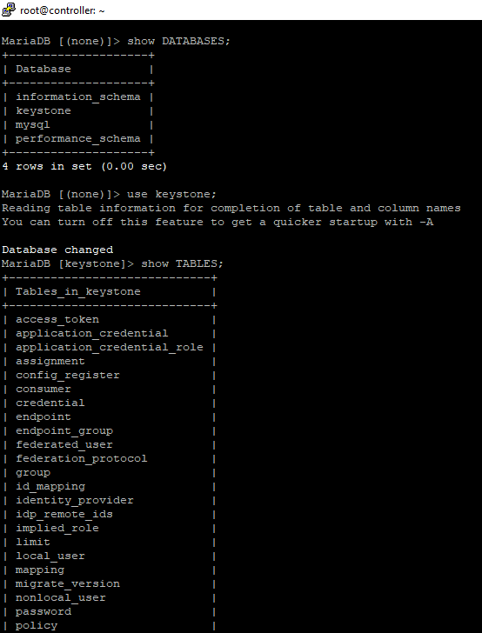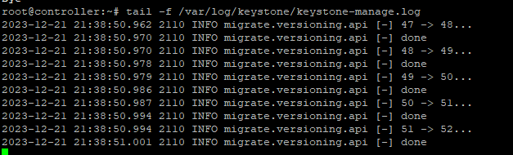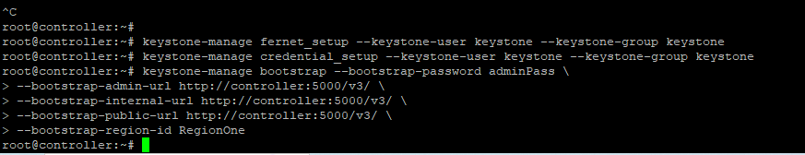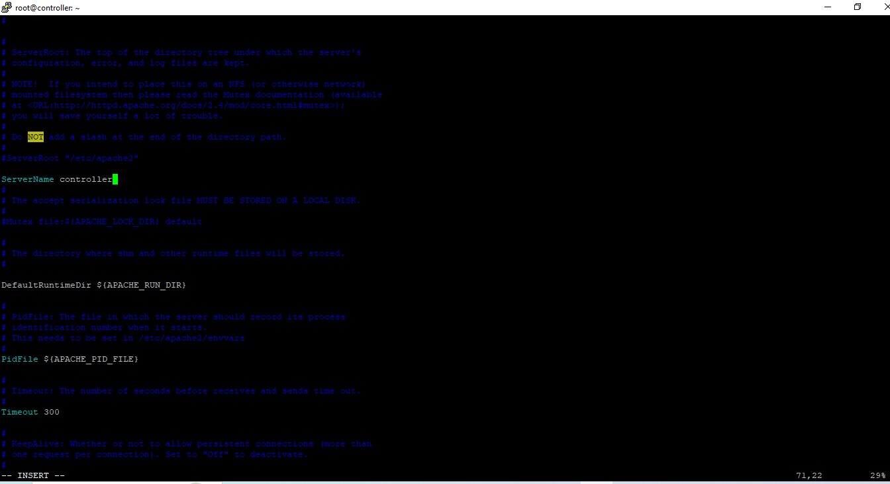

1. **INITIALIZE PARENT KEY RESPONSIBILITIES:**
2. **BOOTSTRAP IDENTITY SERVICE:**
3. **EDIT FILE AND CONFIGURE SERVICE NAME:**
4. **RESTART APACHE SERVER:**

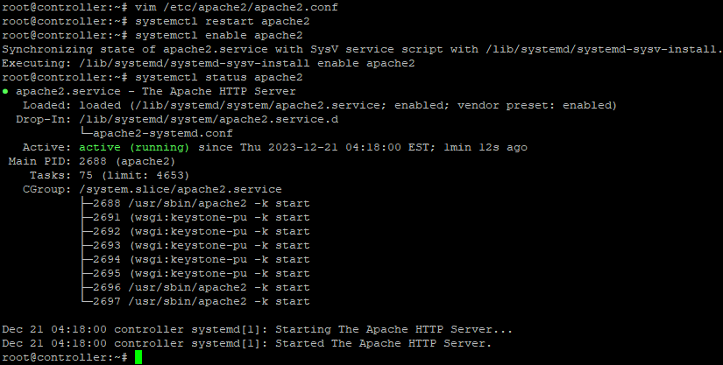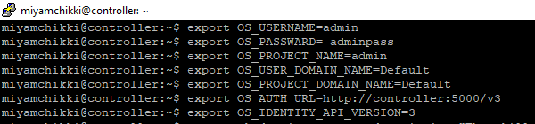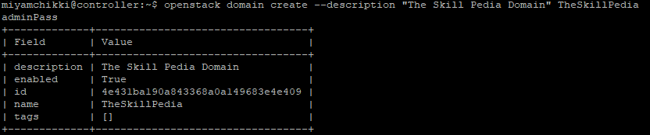

1. **EXIT TO NORMAL USER AND SET ENVIRNOMENT VARIABLE:**
2. **CREATE A DOMAIN, PROJECTS, USER AND RULES:**
3. **CREATE UNPRIVILLAGES THESKILL PEDIA PROJECT:**

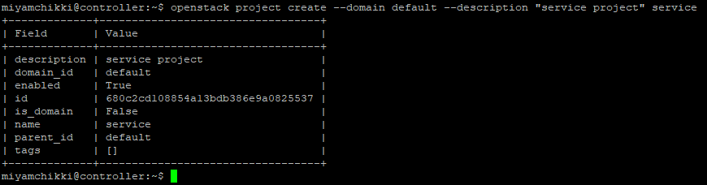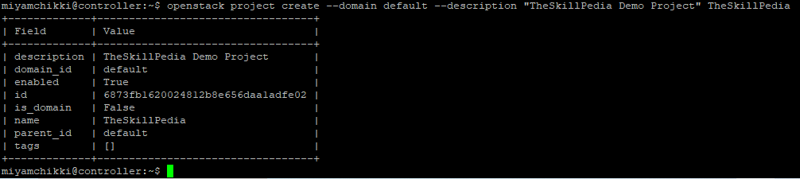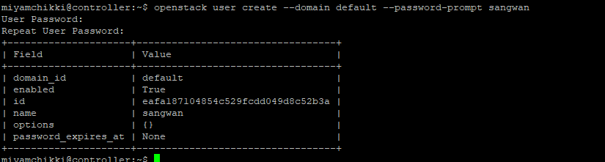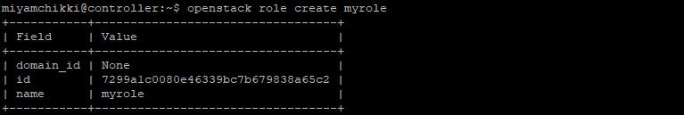

1. **ADD EMPLOYEE TO THESKILLPEDIA PROJECT:**

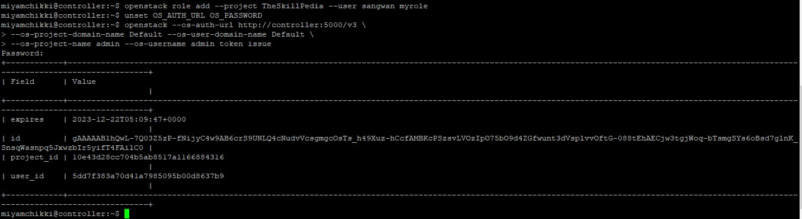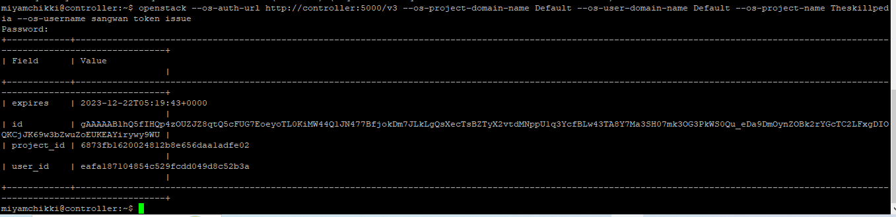

1. **AS ADMIN USER REQUEST AUTHENTICATION TOKEN:**

